PROJECT PROPOSAL
BY: ABRAHIM NISAR
TO: MUHAMMAD AWAIS
Roll no:2025-29 CET 22

TITLE:Quiz System with Result Analysis
Features:
- MCQs stored in arrays
- Timer logic (loop-based)
- Marks & percentage
- Grade calculation

PF Concepts:
- Arrays
- Functions
- Conditions

Algorithm
Step 1: Start
Step 2: Declare and initialize:
- An array of questions
- A 2D array of options
- An array of correct answers
- Variables for user answer, score, and grade
Step 3: Call the Paper() function.
Step 4: Stop
FLOWCHART
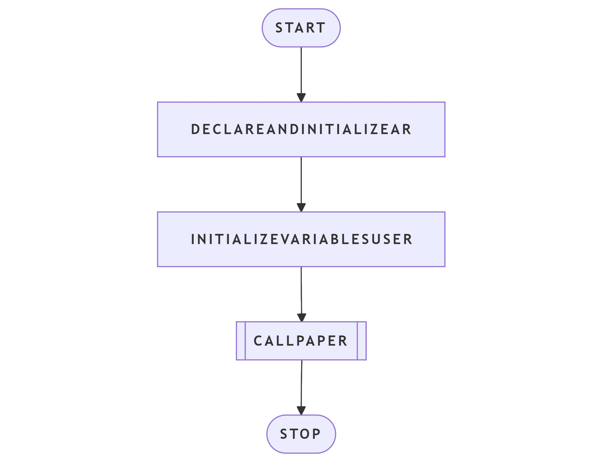

Algorithm for Paper() Function
Step 1: Start
Step 2: For each question from 1 to 5:
Step 3: Display the question number and question text
- Display all four options
  - Display a message: “Enter Your Answer in 10 seconds”
  - Start a countdown timer from 10 to 1:
  - Display remaining time on the same line
  - Delay execution for approximately 1 second
Step 4: Take input from the user
Step 5: Convert the input character to uppercase
Step 6: Compare the user’s answer with the correct answer
Step 7: If correct, increment the score by 1
Step 8: End loop
Step 9: Return control to main()
Step 10: Stop
FLOWCHART

Algorithm for Grade() Function
Step 1: Start
Step 2: Calculate grade percentage using:
- grade = (score × 100) / 5
  - If grade > 90:
    - Display GRADE A+
  - Else if grade > 80:
    - Display GRADE A
  - Else if grade > 70:
    - Display GRADE B
  - Else if grade > 60:
    - Display GRADE C
  - Else:
    - Display YOU ARE FAIL
Step 3: Stop

Main Algorithm
Step 1: Start
Step 2: Call Paper() function
Step 3: Call Grade() function
Step 4: End program
Step 5: Stop
FLOWCHART
